**Minesweeper**

A Dissertation submitted

for the partial fulfilment of the degree of

**Bachelor of Engineering in**

**Computer Engineering**

**(Session 2018 - 2022)**

**Guided By:                                                               Submitted By:**

Mr. Manoj Pawaiya Sir                                    Hritik Sahu (18C7120) Muskan Sharma (18C7130) Vikalp Rusia (18C7163)

**Department of Computer Engineering**

**Institute of Engineering & Technology**

**Devi Ahilya Vishwavidyalaya, Indore (M.P.)**

([www.iet.dauniv.ac.in](http://www.iet.dauniv.ac.in/))

December 2021

# Dissertation Approval Sheet

The dissertation entitled **“Minesweeper”** submitted by **Hritik Sahu, Muskan Sharma, Vikalp Rusia** is approved as partial fulfilment for the award of **Bachelor of Engineering in Computer Engineering** degree by **Devi Ahilya Vishwavidyalaya, Indore**.

**Internal Examiner External Examiner**

**Director**

**Institute of Engineering & Technology**

**Devi Ahilya Vishwavidyalaya,**

**Indore (M.P.)**

# Recommendation

The dissertation entitled **“Minesweeper”** submitted by **Hritik Sahu, Muskan Sharma, Vikalp Rusia** isa satisfactory account of the bonafide work done under my supervision is recommended towards the partial fulfilment for the award of **Bachelor of Engineering in Computer Engineering** degree by **Devi Ahilya Vishwavidyalaya, Indore.**

**Date: Project Guide**

Mr. Manoj Pawaiya Sir

**Endorsed By:**

**Head, Department of Computer Engineering**

# Candidate Declaration

We hereby declare that the work which is being presented in this project entitled Minesweeper in partial fulfillment of degree of Bachelor of Engineering in Computer Engineering is an authentic record of our own work carried out under the supervision and guidance of **Mr.** **Manoj Pawaiya Sir**, **Professor** in Department of **Information Technology**, Institute of Engineering and Technology, Devi Ahilya Vishwavidyalaya, Indore

We are fully responsible for the matter embodied in this project in case of any discrepancy found in the project and the project has not been submitted for the award of any other degree.

**Date:**

**Place:**

|  |  |
| --- | --- |
| Hritik Sahu | (18C7120) |
| Muskan Sharma | (18C7130) |
| Vikalp Rusia | (18C7163) |

# ACKNOWLEDGEMENTS

The success and outcome of this project required a lot of guidance and assistance from many people, and I am extremely privileged to have got this all along the completion of my project. All that I have done is only due to such supervision and assistance and I would not forget to thank them.

I respect and thank our project guide **Mr. Manoj Pawaiya sir**, for providing me an opportunity to do the project work and giving us all support and guidance, which made me complete the project duly. I am extremely thankful to him for providing such a nice support and guidance.

I owe my deep gratitude to **Dr. G.L. Prajapati sir**, HOD Computer Engineering Department, who took keen interest on our project work and guided us all along, till the completion of our project work by providing all the necessary information for developing a good system.

I would not forget to remember Director of Institute of Engineering and Technology DAVV, **Dr. Sanjiv Tokekar sir** for their encouragement till the completion of our project work.

# ABSTRACT

* Minesweeper is a simple one−player computer game. The game consists of a 2-dimensional rectangular playing field (or board) where known numbers of mines are hidden.
* Our web-based interactive game keeps the user engaged for a long time. Not only it sharpens one’s reasoning power but also refreshes them. This thesis will cover implementation of real time graphics. We used agile development/ evolutionary development for the development of the project.
* Our solution mainly focusses on implementation and improvement parts.
* We learnt URL encoding of various types used in sending fetch queries, beacon queries.
* UI designs such that user likes them, and the user can upload his Avtar
* Sending verifications mail.

Table of Contents

Dissertation Approval Sheet i

Recommendation ii

Candidate Declaration iii

ACKNOWLEDGEMENTS iv

ABSTRACT v

Table of Figures vii

Chapter-1 Introduction 1

1.1 Overview 1

1.2 Problem Definition 1

1.3 Proposed Solution 3

Chapter-2 Literature Survey 4

Chapter-3 Analysis 6

3.1 Software Requirements 6

3.2 Hardware Requirements - 6

3.3 Use Case Model 7

3.4 Use Case Description 7

Chapter-4 Design 10

4.1 Technology Selection 10

4.2 Packaging 10

4.3 Database Design 10

Chapter-5 Implementation 11

5.1 Subsystem and their dependencies (Maven) 11

5.2 Modular dependency 12

5.3 Class diagram 13

Chapter-6 Conclusion 14

References 16

# Table of Figures

Fig. 1.1 Unopened canvas 2

Fig. 1.3 Opened canvas 2

Fig. 1.4 Marked mine 2

Fig. 1.5 Mine clicked 2

Fig. 3.1 Use case diagram 7

Fig. 4.1 ER diagram 10

Fig. 5.1 Maven java dependency 11

Fig. 5.2 Complete dependency 12

Fig. 5.3 Class diagram 13

# Introduction

## Overview

* Minesweeper is a single-player puzzle video game. The objective of the game is to clear a rectangular board containing hidden "mines" or bombs without detonating any of them, with help from clues about the number of neighboring mines in each field.
* There are some benefits of playing games like minesweeper:
  + Using Games to Teach Cognitive Skills – The use of games to attempt to teach cognitive skills goes back to ancient times. For ex- Go, Chess.
  + The Value of Logical Hypothetical Thinking - Hypothetical reasoning is a central topic in cognitive science. and is a major component of what is known in Dual Processing Theory as Type 2 Processing done by our brains.

## Problem Definition

* Minesweeper is a simple one−player computer game. The game consists of a 2-dimensional rectangular playing field (or board) where known numbers of mines are hidden.
* Initially, all the squares on the board are "covered up" and no information is given to indicate the location of the mines.
* The player’s job is to either deduce or guess which board squares are clear of mines and step there to reveal a number.
* If successful, this number will indicate the number of mines to be found in the squares adjacent to the square with the number.
* Obviously, the first move of the game must be a guess because no information has been provided. Since the board is a rectangular grid, each interior square has exactly 8 neighboring squares, edge squares have 5 neighbors, and corner squares have 3 neighbors.
* Therefore, the number found under any given square will be in the range of 0 to 8 (inclusive).
* Game play continues until the player has uncovered (or "stepped" on) each square that does not hide a mine, while avoiding all the mines. If the player can do this, they are considered to have won the game.
* However, if at any point the player attempts to uncover a square that contains a mine, the game immediately ends, and the player

is said to have lost.

|  |  |
| --- | --- |
| unopened canvas  Fig. 1.1 Unopened canvas | opened minesweeper  Fig. 1.2 Opened canvas |
| marked cell in minesweeper  Fig. 1.3 Marked mine | opened mined and loose  Fig. 1.4 Mine clicked |

## Proposed Solution

Key points-

* UI redesigned from scratch to meet up the current world requirements. UI is a lot interactive to retain player. User gets lot of option.
* Though there are no themes for now but in future releases they have a reserved spot.
* Profile page contains dynamic data to update the profile of user from password to username as well as avatar. Leaderboard contains data for separate levels.
* To improve upon the game-
  + There are several features that could be added. For example, adjusting the program to ensure that a bomb could not be uncovered on the first tap.
  + This could be done by generating the random row and column coordinates of the bomb locations in the gameboard array after the first touch had been recorded on the touch screen.
  + An if statement could be used in the code to prevent a bomb from being randomly placed in the location that corresponds to a location that was already touched by the user on the screen.
  + By generating the location of the bombs after the first touch has been made by the user, there is no way that the user could touch a bomb on the first touch. Then, the remaining logic of the code could still be applied.
  + Another recommendation for the game is that flags could be added to the game. this would involve adding a button board that could be used to select locations on the board that the user suspects to have a bomb.
  + Then, the user could tap these locations and a shape could be printed to that desired location. An if statement could be used to allow for the user to tap the space again to remove the shape. These changes could be implemented with more time.

# Literature Survey

Key points-

* Minesweeper is under rated game as only 2 sites are currently serving minesweeper.
* First site is hosted by google which has descent UI, but the game is not customizable as well as there is no leaderboard.
* Second site is hosted by minesweeper.online which has poor UI as compared to the growing power of UI in current world.
* Currently players cannot upload their avatar as well as there is no community to chat.
* They are not able to retain people because of this.

Early algorithms developed to solve Minesweeper focus on the deterministic deductions needed to uncover safe moves. Adamatzky modeled Minesweeper as a cellular automaton or CA [1]. The cell state is given two components. The first component indicates whether the cell is either covered, uncovered, or a mine. The second component, which is only available to the system if the cell is uncovered, is the number of mines adjacent to that cell. One limitation to the CA model is in the transition function which only accounts for two basic deductions in Minesweeper. However, its main weakness is its tendency to become stuck on configurations. Since the CA solver is deterministic, it never makes guesses or random moves, an occasionally necessary step in completing a game especially at harder difficulties. Adamatzky expressed the need for stochastic features necessary for future algorithms.

A single point algorithm was mentioned by Kasper Pederson [2], although it was known beforehand, specifically by the author of Programmer’s Minesweeper or PGMS1. Although not mentioned here, section 5.2 will analyse the single point algorithm in PGMS in more detail. Nevertheless, Kasper’s single point method determines safe moves deterministically by looking at individual squares, like CA. However, if no safe moves are discovered, a square is probed uniformly at random. This prevents the algorithm from becoming stuck. Nevertheless, this approach is still too naive which is underscored by the poor performance on harder difficulties where guessing becomes more prominent.

Kasper Pederson offers an alternative strategy called limited search. This method utilizes depth-first search and backtracking on a small zone of interest around uncertain squares, an idea suggested by Pe˜na and Wrobel [3]. Since deductions often involve constraints placed on squares that are not direct neighbours, this technique can deduce more safe moves than the single point counterpart. Furthermore, Pederson added probability estimations that allowed for “smart” guessing. By collecting solutions from the limited search, estimates could be made about the probability of mines locations. Squares determined to have a low probability of being a mine would then be chosen as smart guesses, an improvement from simply probing uniformly at random.

# Analysis

## Software Requirements

|  |  |
| --- | --- |
| Tool/Technologies | Description/Justification  Operating |
| Operating System | Any modern OS can be chosen for development  of Minesweeper Game. |
| MySQL | MySQL is to be used as a database to save the  login credentials of a user and their respective  data. |
| JDBC | JDBC makes it possible to establish a connection  with a data source and extract data from a  database. |
| Hibernate | Primary feature of hibernate is mapping from  Java classes to database tables, and mapping  from Java data types to SQL data types. |
| HTML, CSS, JavaScript | Front-End of application is to be developed using  HTML, CSS, and JavaScript. |
| Java | To implement the project, Java was chosen as a  platform for its more interactive community and  lots of libraries. |
| IntelliJ Idea | IntelliJ IDE is to be used as the main  development tool to develop this project. |
| Web Browser | Minesweeper Game can be developed and  tested with any of the modern web browsers. |

Table 3.1 Software Requirements

## Hardware Requirements -

|  |  |
| --- | --- |
| Hardware | Justification |
| Computer | For running web browser |
| Server | For deploying web app |

Table 3.2 Hardware Requirements

## Use Case Model

Fig. 3.1 Use case diagram

## Use Case Description

Use case description of each use case in the use case model must be there and it must be properly numbered and according to the format. In a particular use case description don’t simply write the Preconditions, Post conditions and Special Requirements as none before analysing the particular use case in detail.

1. Register -

Precondition - Server should be running and the browser can connect properly.

Postcondition - Browser can redirect users.

It registers users.

1. Log In -

Precondition - User should be registered for Log In.

Postcondition - Browser can redirect users.

It logs-in users.

1. Delete account –

Precondition - User should be Logged In.

Postcondition - Browser can store a token.

It deletes users.

1. Play Game –

Precondition - User should be Logged In.

Postcondition - Browser can redirect users.

Users can play games having 3 levels - EASY, MEDIUM, HARD.

1. How to play-

Precondition - User should be Logged In.

Post condition - None

It teaches users to play minesweeper.

1. View High Score –

Precondition - User should be Logged In.

Postcondition - Browser can render HTML.

It displays high Score.

1. Leader board –

Precondition - User should be Logged In.

Postcondition - Browser can redirect users.

It displays user High score.

1. Contact us –

Precondition - User should be Logged In.

Postcondition - Browser can redirect users.

It allows users to communicate with us.

1. Total player –

Precondition - User should be Logged In as admin.

Postcondition - None.

It displays all users.

1. Online player –

Precondition - User should be Logged In as admin.

Postcondition - None.

It displays currently active users.

1. Attempt/Time –

Precondition - User should be Logged In as admin

Post condition - None

It displays all time and attempt time.

# Design

## Technology Selection

* Java- To implement the project, Java was chosen as a platform for its more interactive community and lots of libraries.
* MySQL- It is to be used as a database to save the login credentials of a user and their respective data. JDBC makes it possible to establish a connection with a data source and extract data from a database.
* Hibernate- The primary feature of hibernate is mapping from Java classes to database tables, and mapping from Java data types to SQL data types.
* HTML, CSS, JavaScript- Front-End of application is to be developed using HTML, CSS, and JavaScript.

## Packaging

War packaging using maven plugin for deployment in tomcat

## Database Design

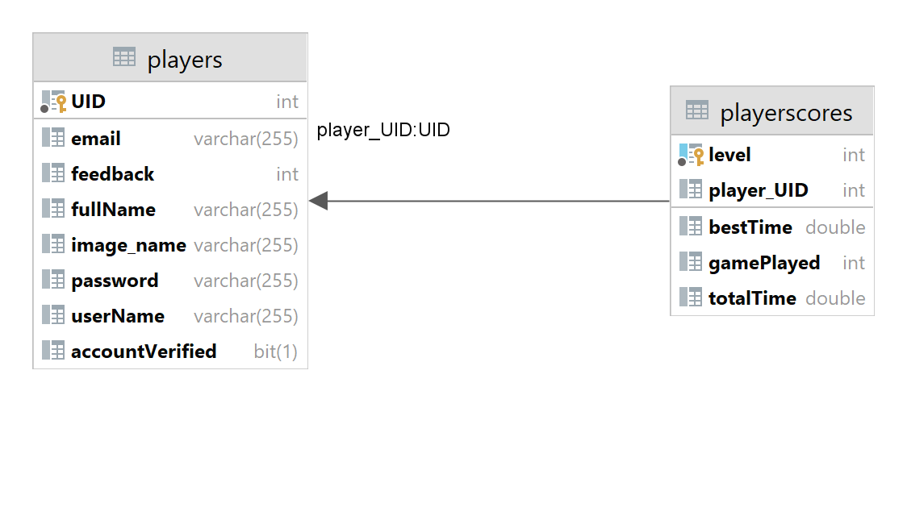

Fig. 4.1 ER diagram

# Implementation

## Subsystem and their dependencies (Maven)

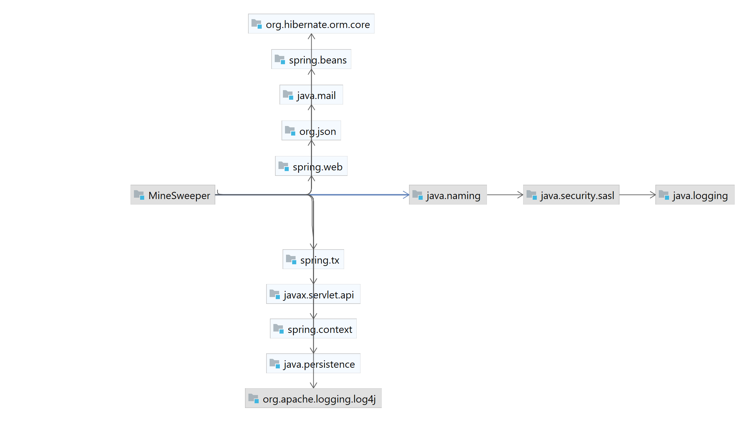

Fig. 5.1 Maven java dependency

## Modular dependency

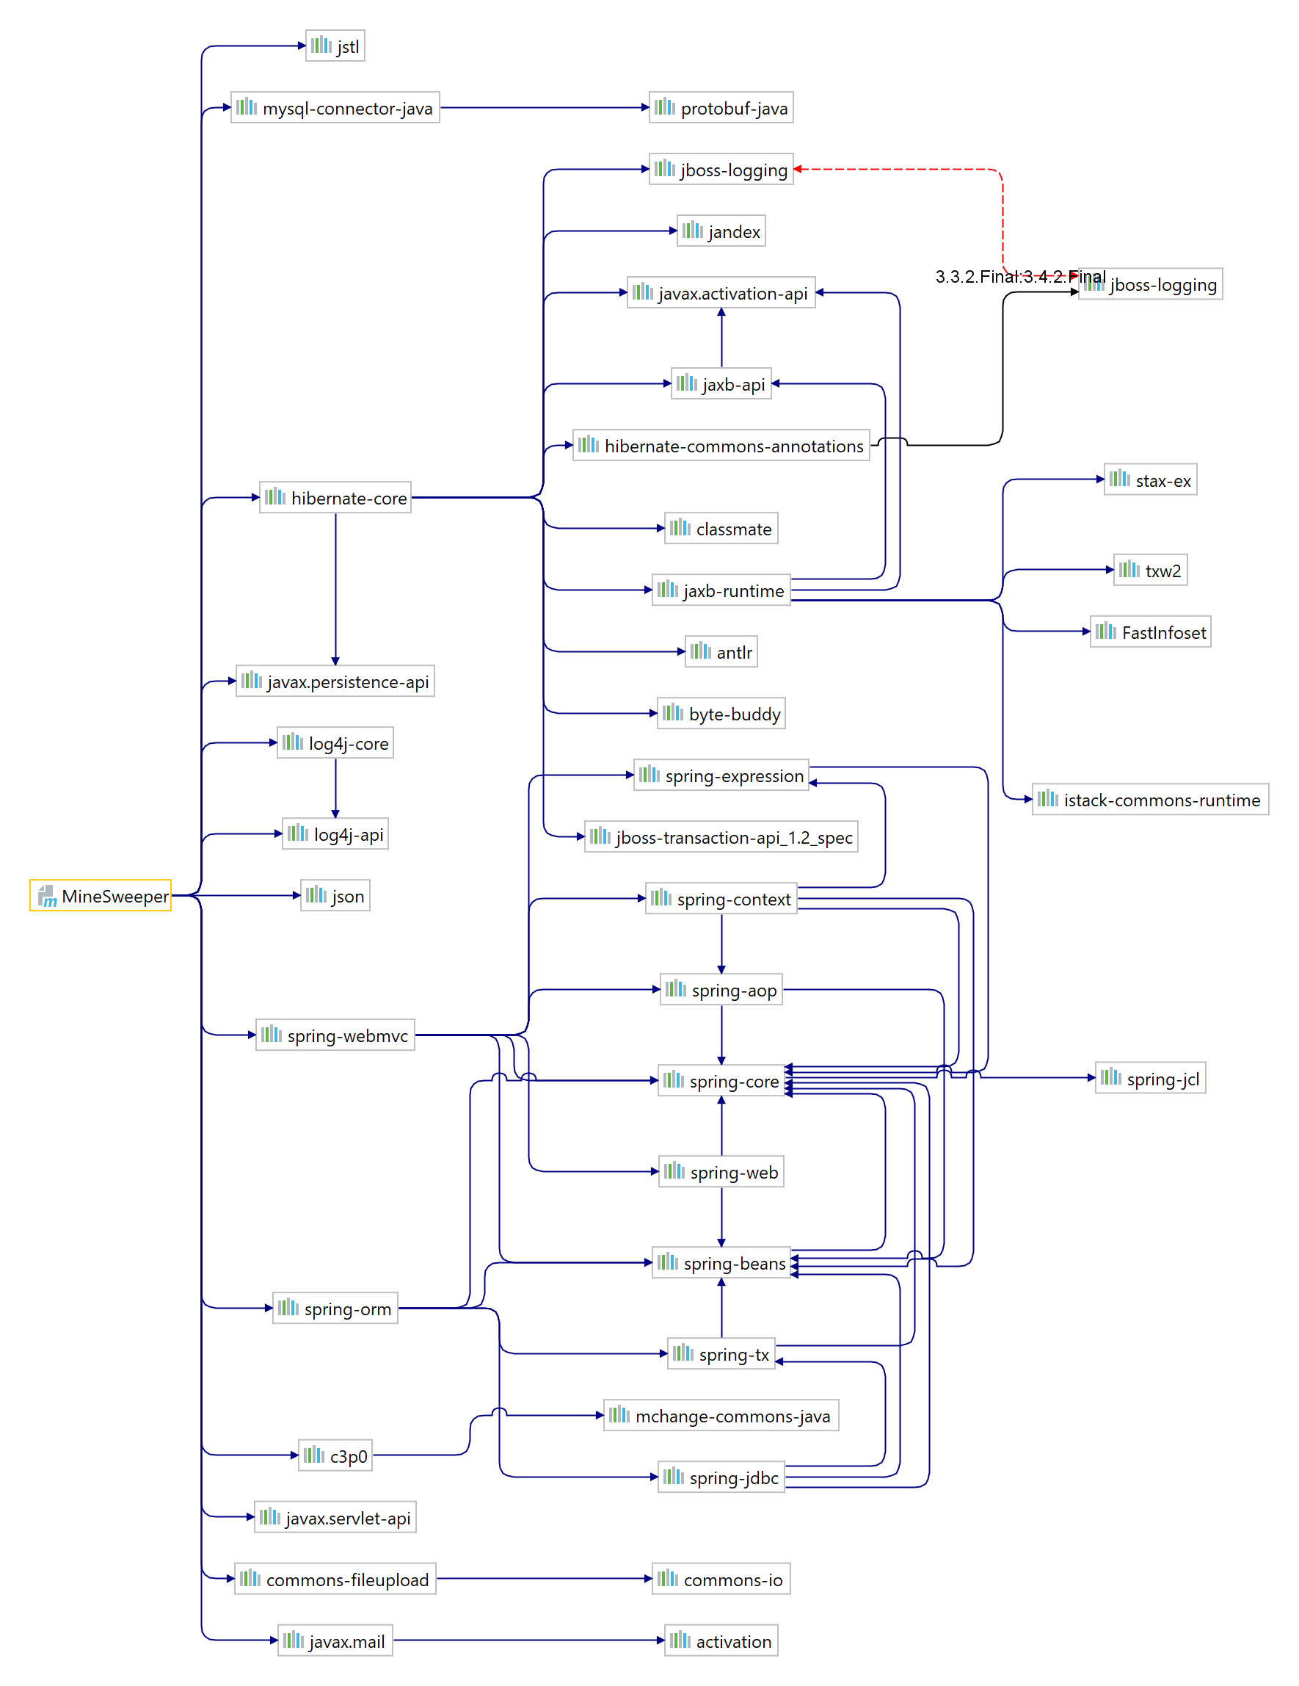

Fig. 5.2 Complete dependency

## Class diagram

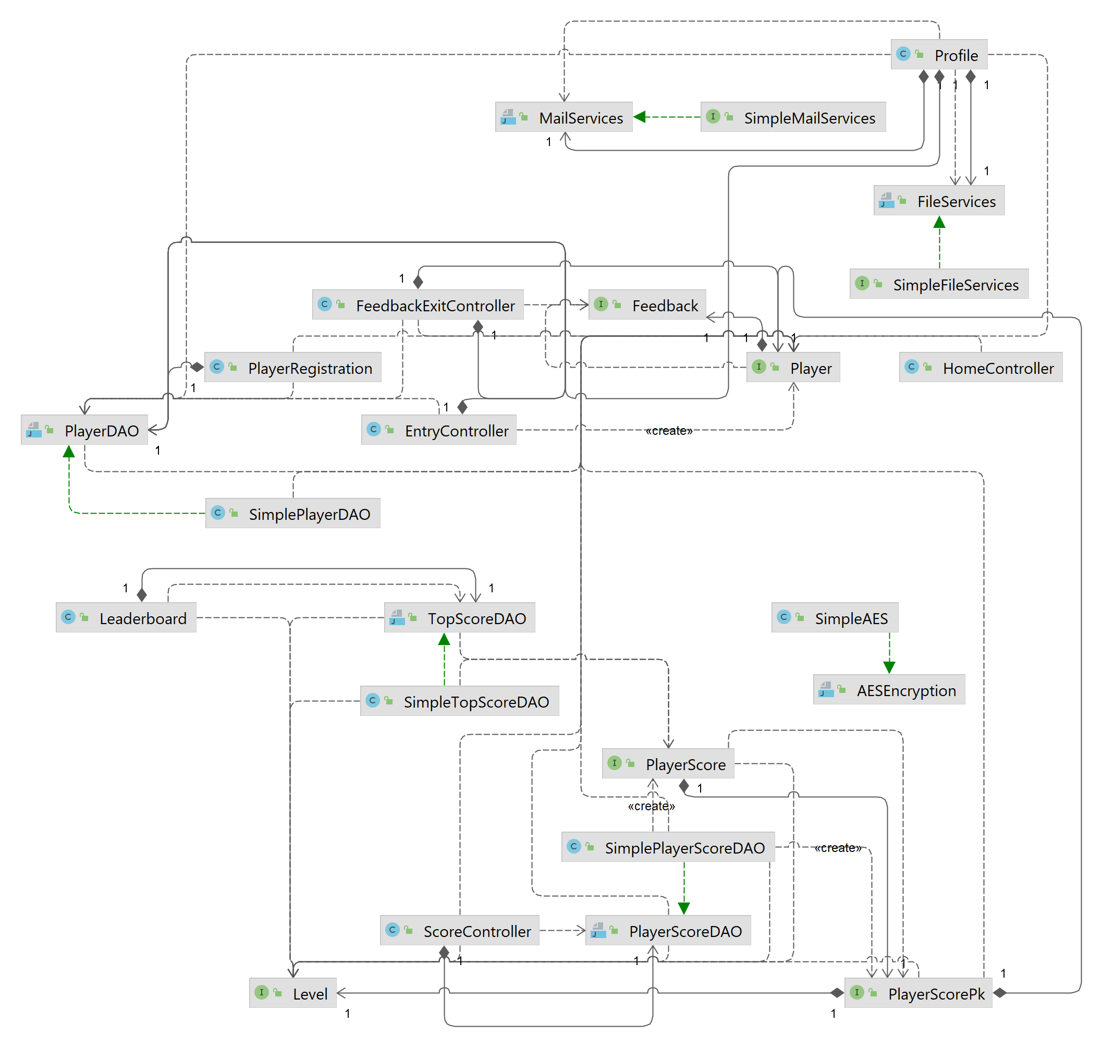

Fig. 5.3 Class diagram

# Conclusion

Key points-

* Difficulties faced-
  + Default theme selection for whole website which includes – font size, color but is not limited to this only.
  + JavaScript fetch, beacon queries and how to capture them at backend.
  + Configuring backend for logging server state and client state.
  + Using web URL encoding for integrating spring form with fetch queries.
* Future releases include-
  + Theme selection
  + Captcha validation to avoid DNS attack
  + Email verification
  + Contact us (in website)
  + Using Jtoken for validation
  + Delete Account

During the process of creating the game, there were several obstacles that were encountered. For example, there was difficulty in developing a way all the surrounding locations of a selected location could be checked for mines. This problem was solved by making an if-else selection structure that could check the values of the surrounding locations in the array that represented the game board. This was done by incrementing the indices of the array by different values depending on the location on the screen. For example, the corner locations each had a different set of locations to check. The top right corner must check the location below, below to the left, and the location to the left.

Another difficulty that was encountered was developing a method to win. This was done by changing the values in the game board array that correspond to touched locations to equal two. Then, after each touch, the components of the array are summed and compared to the value of the array if all the non-bomb locations had been touched, changed to a value of two, and summed with the value of the bomb locations. Once the sum is reached, the user has cleared the minefield and won the game. This solution took planning and trial by error.

The final difficulty that was encountered was difficulty in testing the game because the mines were randomly generated. To solve this problem, the randomly generated mines were commented out and bombs were manually placed in certain locations. This allowed for the testing of the game. In terms of things that worked well, for loops used to draw the boards worked well and made symmetric boards. Additionally, once the method for checking the surrounding locations of a selected location was developed it worked well in printing the number of surrounding bombs.

# References

1. Andrew Adamatzky. How cellular automaton plays minesweeper. Applied Mathematics and Computation, 85(2–3):127–137, 1997.
2. Kasper Pedersen. The complexity of minesweeper and strategies for game playing. Project report, univ. Warwick, 2004.
3. Lourdes Pe˜na Castillo and Stefan Wrobel. Learning minesweeper with multi relational learning. In IJCAI, pages 533–538, August 2003.
4. Minesweeper as a Constraint Satisfaction Problem
5. Minesweeper and Hypothetical Thinking Action Research & Pilot Study (ed.gov)
6. <https://en.wikipedia.org/wiki/Minesweeper_(video_game)>
7. <https://www.google.com/fbx?fbx=minesweeper>
8. <https://www.pcworld.com/article/482195/how-to-play-minesweeper-like-a-pro.html>
9. [How to play Minesweeper](https://www.google.com/url?sa=t&rct=j&q=&esrc=s&source=web&cd=&cad=rja&uact=8&ved=2ahUKEwiO8eny7_b0AhVCw4sBHSg1CewQwqsBegQIWhAB&url=https%3A%2F%2Fwww.youtube.com%2Fwatch%3Fv%3D7B85WbEiYf4&usg=AOvVaw2Z2QIJ9AurE5EENt7W7zUl)
10. <https://leetcode.com/problems/minesweeper/>
11. <https://www.minesweeper.info/>